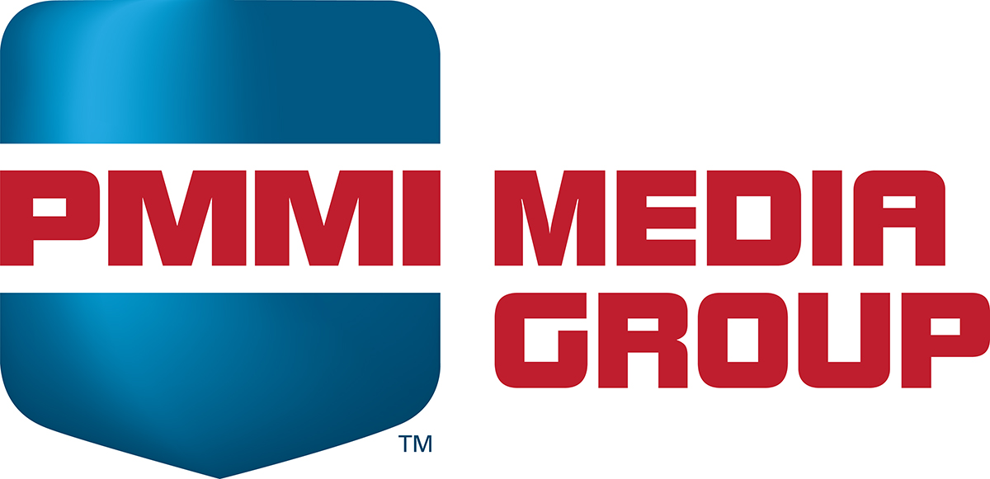
Tips for Top-Performing Email Content

Competition for reader engagement is increasingly challenging. To best support email open rate and click through, below are some best practices for subject lines, body text and calls to action based on PMMI Media Group audience trends.

Subject lines

- Keep it short—generally less than 50 characters (mobile shows 25-30); 6-10 words
- Focus on the user’s industry vs. yourself (especially if a well-known CPG category or CPG company)
- Focus on educating around a pain point instead of promoting your company or product name (“No more clogged printheads” vs. “750-881 – The Printmaster”)
- Provide specifics (especially with numbers): “5 Ways,” “10 Must-Knows” or any statistics
- Use “hot” terms when applicable: IIoT, food safety, outsourcing, serialization (or other regulatory issues to tie you to something bigger)
- Be targeted in approach: A subject line “Cut downtime by 5 percent” is less useful than “New filling approach cuts downtime by 5 percent.” The goal isn’t simply number of opens, but opens from those who could be potential customers or have interest in the particular solution
- Avoid common spam trigger words, such as “free” or “win” or “click,” and the use of symbols (see list at end)
- Ensure subject line matches content. An overly vague (“Guess what’s coming”) or excessively sensational statement (“Most innovative bagger ever”) may be good for one open—but instantly erodes trust in the brand if what’s delivered doesn’t meet expectations. No one likes click bait!
- Avoid hard sells “Model 360: The Game Changer”

Some key rules to follow to avoid triggering SPAM:
- Don’t add “RE:” to subject lines if it’s not a reply
- Don’t use all caps (unless it’s a common regulatory acronym or the like)
- Don’t use one- or two-word subject lines
- Avoid unusual punctuation (periods at the end of subject lines, ellipsis use)
- Most money words are usually not good to use, but exceptions could be: “cost,” “profit,” “save,” and “savings” based on context.

Email Content

- Hint at what will be revealed, but don’t reveal until they click
- Promise a payoff in knowledge – what people will learn by reading "The truth about energy efficient motors"
- Action-oriented: What action can they take after reading your piece?
- Tie into current issues in popular or business press (China, in-sourcing, etc.)
- Drop names of well-known companies or well-respected industry experts
- Tout results: “How a $10K investment saved $3 million in 6 months”
- Induce fear and anxiety if they DON’T read your piece (“New rules impact...”)
- Ask a question! The implication is you have to click to find out the answer.
- Don’t summarize! That just provides a reason NOT to click. ("Thanks for telling me what that's about – saves me from having to click to find out!")

Calls to Action

- Offer something that's worth clicking on: a white paper, video, assessment tool, survey results, strategy brief, Q&A with industry expert, sneak peek at a technology roadmap, etc.
- Try a different offer with each newsletter, or same offer, new copy
- Ad copy should sell them on clicking on the offer, NOT your product, service or company. For example, instead of selling the Model 5300, sell them on what they'll learn by downloading the paper or watching the video
- Think book jacket copy: Sell what's inside and what's going to happen after they click!

LIST OF COMMON TRIGGER WORDS & SYMBOLS

#
%
$
Act
Amazed
Amazing
Apply
Bonus
Buy
Call
Cash
Cheap
Clearance
Click
Congratulations
Credit
Debt
Discount
Drawing
Earn
Email
Enter
Expire
Extra
Fantastic
Free
Freedom
Friend
Great
Guarantee
Hello
Income
Instant
Investment
Limited
Luxury
Money
Name
Now
Obligation
Offer
Only
Open
Order
Paid
Please
Price
Promise
Purchase
Quote
Rates
Refinance
Refund
Request
Risk-free
Sales
Satisfaction
Score
Serious
Success
Supplies
Take action
Terms
Traffic
Trial
Unlimited
Urgent
Weight
Win
Winner

