Creating/Attaching an Agency to an advertiser:

Setting up an Agency:

- Create Agency Company record:
  - Fill in Company Name, Address, Phone number and Website
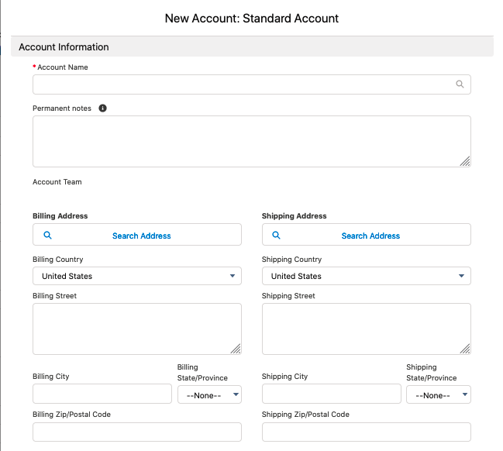

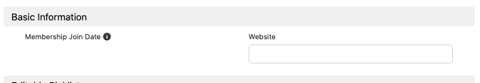

  - Check the “Agency” Box

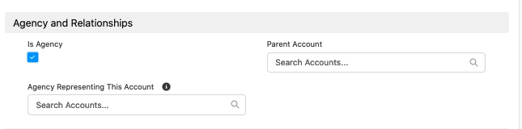

  - Check the “Naviga Leadworks Sync” Box

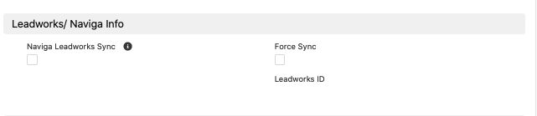

  - Click Save

- Create the contacts at the agency (in this company record)
  - Enter First Name, Last Name and Email address.
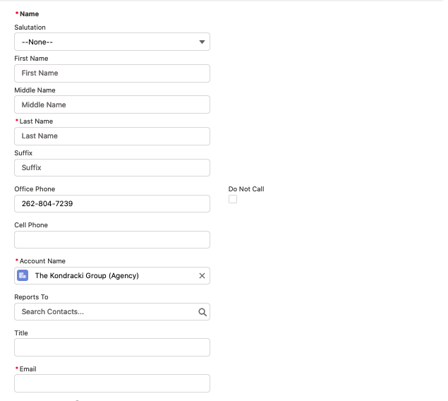
  - Click Save
  - Edit their Relationship.
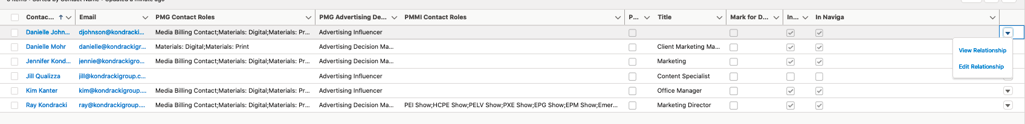
  - Select their Role in our advertiser’s Account (Advertiser Decision Maker, Digital and/or Print Material Contact or Billing Contact.
  - Save
  - If the contact(s) do not sync with Naviga after saving, you can use the force sync box if you need the contact right away. Otherwise, they should sync overnight.

*** Note: The agency will not have a company listed under “Agency Representing This Account”. If you see something there, you have something connected incorrectly.

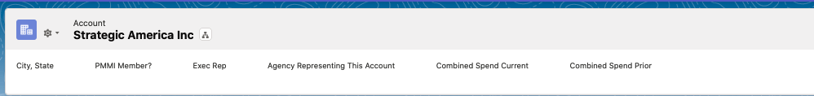

Attaching the Agency to the client:
- Create the company or open the existing company
- Scroll down to “Agency and Relationships”
- Click the edit pencil next to “Agency Representing This Account”
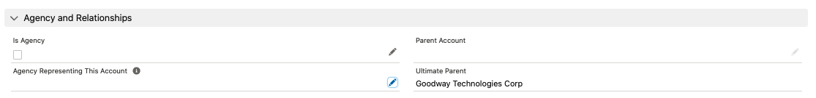

- Start typing the name of the Agency and select the Agency from the list of choices.
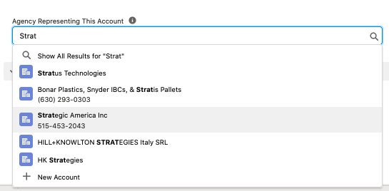

- Save
- You will know you connected them correctly when you see the name of the Agency under “Agency Representing this Account” at the top of the company screen.

